SYNC LAB (WE WILL USE OUR EXISTING PROJECT WHICH WE CREATED IN LAB1 )

Step 1 — Go to your repository
You should already be here:
cd /home/ubuntu/flipkart-gitops
Verify:
pwd
Expected:
/home/ubuntu/flipkart-gitops
Step 2 — Add Wave 1 to Product
Open:
nano child-apps/product-app.yaml
Inside metadata, add this annotation:
metadata:
name: product
namespace: argocd
annotations:
argocd.argoproj.io/sync-wave: "1"
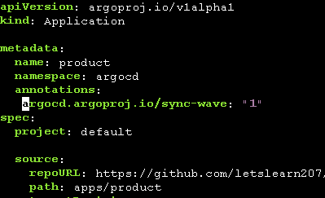
So the beginning should look like:
apiVersion: argoproj.io/v1alpha1
kind: Application
metadata:
name: product
namespace: argocd
annotations:
argocd.argoproj.io/sync-wave: "1"
spec:
project: default
Save:
Ctrl + O → Enter → Ctrl + X
###
Step 3 — Add Wave 2 to Cart
Open:
nano child-apps/cart-app.yaml
Change the metadata to:
metadata:
name: cart
namespace: argocd
annotations:
argocd.argoproj.io/sync-wave: "2"
So:
apiVersion: argoproj.io/v1alpha1
kind: Application
metadata:
name: cart
namespace: argocd
annotations:
argocd.argoproj.io/sync-wave: "2"
spec:
project: default
Save:
Ctrl + O → Enter → Ctrl + X
Step 4 — Verify the changes
Run:
grep -A2 sync-wave child-apps/*.yaml
You should get something like:
child-apps/cart-app.yaml:
argocd.argoproj.io/sync-wave: "2"

child-apps/product-app.yaml:
argocd.argoproj.io/sync-wave: "1"
So now:
Product = Wave 1
Cart = Wave 2
Step 5 — Commit the changes
Check Git:
git status
You should see:
modified: child-apps/cart-app.yaml
modified: child-apps/product-app.yaml
Now:
git add child-apps/
Then:
git commit -m "Add sync waves"
Then:
git push origin main
Your GitHub repository now contains the desired Sync Wave configuration.
(This is mandatory step as you should commit and push the change if you want Argo CD to see it)

